

**UNIVERSIDAD DE LAS FUERZAS ARMADAS -ESPE**

**DATE:**

17/05/2024

**CLASS:**

OOP - 14541

**HOMEWORK TOPIC:**

Write the possibles requirements of your project

| 1 | ACUÑA GAMBOA CHRISTIAN MARCELO |
| --- | --- |
| 2 | ARBOLEDA ROMAN ABNER DAVID |
| 3 | ARMIJOS MACAS ENZO ALBERTO |
| 4 | AYUQUINA NAVAS DANNY MATEO    YouTube Link: <https://youtu.be/8PJrvsSqGOY> |
| 5 | BONIFAZ VASQUEZ CHRISTIAN MATEO |
| 6 | CAÑARTE GALARZA SARAY ADRIANA |
| 7 | CEDEÑO CUENCA ANDRES ISAIAS |
| 8 | CEDEÑO REYES NAHOMI NAYELY  YouTube Link: <https://youtu.be/Y2kUwmzxY6k> |
| 9 | CHANATAXI QUIMBIAMBA MARCO VINICIO |
| 10 | GAVILANEZ OCAMPO KENNY JESUS |
| 11 | GUALOTUÑA AMAGUAYA BRAYAN PATRICIO |
| 12 | LISINTUÑA CORREA CRISTIAN MATEO |
| 13 | MÁRQUEZ QUIROZ JENNIFFER PAOLA |
| 14 | MEDINA AUQUILLA NATHALY SIMONE |
| 15 | MORILLO CUEVA DAVID ARIEL |
| 16 | PANTOJA JIMENEZ CARLOS DAVID    Link to video: <https://youtu.be/0bCY882B1yg> |
| 17 | PEREZ CONDOR CARLOS ANDRES |
| 18 | TRAVEZ CACHAGO ALEX ISMAEL |
| 19 | RODRIGUEZ VILLARROEL DAVID JOSUE |
| 20 | SEGARRA DIAZ EDUARDO ANDRES    Link of the video: <https://youtu.be/iVWI_iaruzE> |
| 21 | VACA ZURITA LUIS EDUARDO |
| 22 | VALENCIA BUSTAMANTE YULIANA ANAHI |
| 23 | VILLAGÓMEZ FREIRE DOMENICA NICOLE |
| 24 | VITERI AVILA ALEXIS JHOSUE |

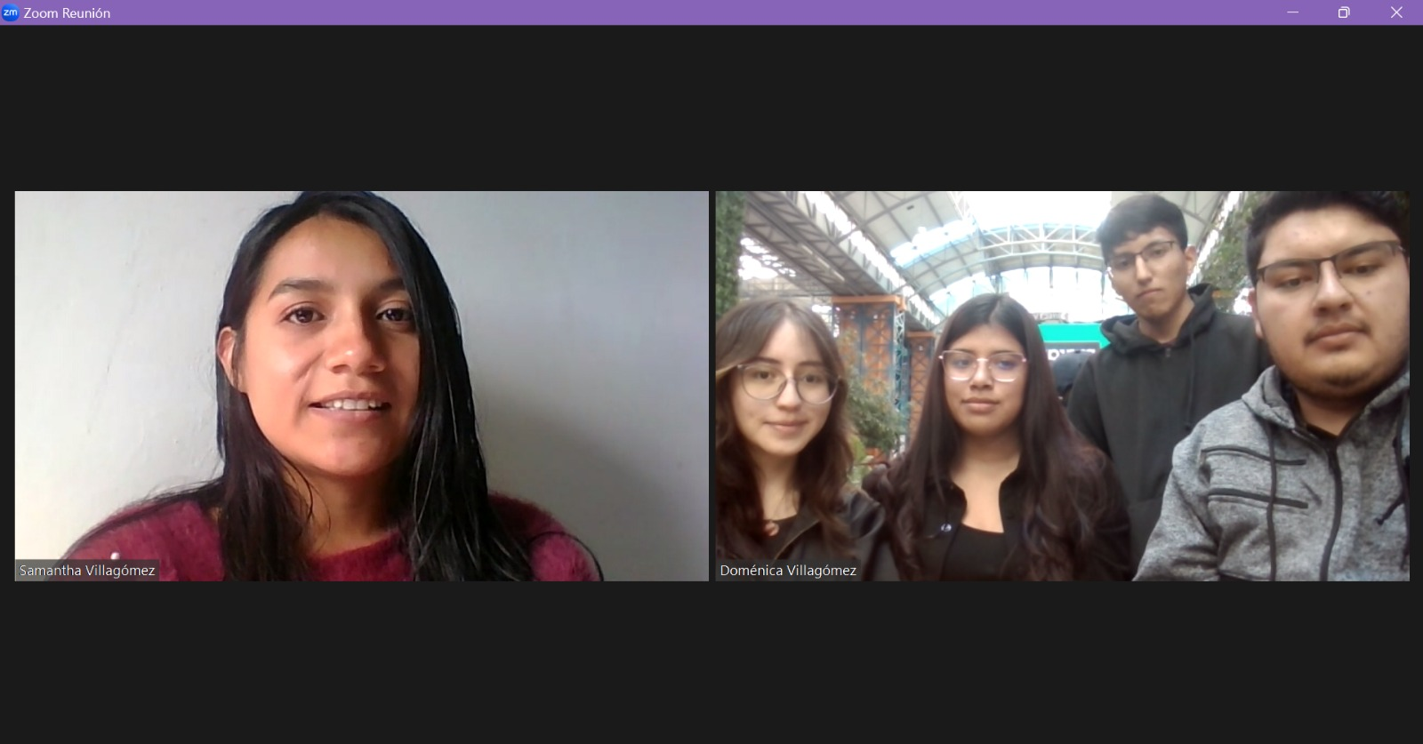

YouTube Link: <https://youtu.be/EBnqSsu7ahw>